Directions to Service

- Take I-70 to Colorado Blvd and go south.

- Proceed south on Colorado until you get to 23rd Avenue, turn
right.

- Drive past the zoo on your left. Drive down the road and turn left into the park. If you get to the York Street, you went too far.

4. Drive past the tennis courts on your left and enter the round-
about. Take the 4th road. You should be approaching the tennis courts again, they will be on your left.

5. Follow the road as it curves to the right and drive thru the
access gate. We will have a brown gazebo tent set up. If you pass the playground, you again went too far.

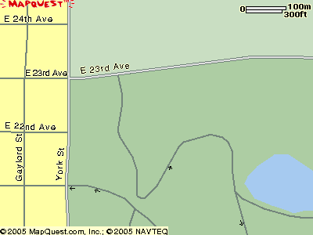
Round about
Service

